孩兒草（爵床科），在臺灣新歸化的植物

陳志雄1、王秋美1,＊

**A Newly Naturalized species in Taiwan: *Rungia pectinata* (L.) Nees (Acanthaceae)**

Chih-Hsiung Chen(1) and Chiu-Mei Wang(1＊)

1 國立自然科學博物館生物學組Department of Biology, National Museum of Natural Science

*通訊作者，404023 台中市北區館前路1號

*Corresponding author. 1, Guancian Rd., Taichung 404023, Taiwan.

E-mail: cmwang@nmns.edu.tw; Fax: 886-4-23258684

孩兒草（爵床科），在臺灣新歸化的植物

【摘要】孩兒草（*Rungia pectinata*）屬於爵床科，已在臺灣南部歸化，主要發現於開放環境的低矮草生地；該物種原產於阿拉伯半島南部、以及亞洲的熱帶和亞熱帶地區。本文提供了分類描述、檢索表和照片以供識別。

【關鍵詞】爵床科，歸化植物，孩兒草，臺灣，分類。

**A Newly Naturalized species in Taiwan:*****Rungia pectinata* (L.) Nees (Acanthaceae)**

【Abstract】*Rungia pectinata* (L.) Nees (Acanthaceae) is a recently naturalized plant in Taiwan, recorded in the southern region, primarily thriving in sunny, open low grasslands, originating from the Southern Arabian Peninsula, as well as tropical and subtropical Asia. Comprehensive descriptions, a key, distribution map, and images of the species are provided.

【Key words】Acanthaceae, naturalized plant, *Rungia pectinata*, Taiwan, Taxonomy.

**INTRODUCTION**

The genus *Rungia* Nees (Acanthaceae) is primarily found in the tropics of the Old World and has been placed in *Justicia* L. on the basis of several morphological characters, both of which have elastic placentae (Kiel et al., 2017). This genus contains about 50 species, with 16 species documented in China (Hu et al., 2011; Rueangsawang et al., 2020). Among these, two species of *Rungia* are listed in the *Flora of Taiwan* 2nd edition. One is *Rungia taiwanensis*, which is native to Taiwan, while the other, *R. chinensis*, is found along the eastern edge of Asia (Hsieh and Huang, 1998). Recently, in our botanical exploration, *Rungia pectinata* was collected in southern Taiwan. After one year of observation and recording, we determined that there are stable populations. Based on Taiwan's geographical location, the closest native habitat is in southern China, and due to its medicinal use in China, we infer that it was introduced to Taiwan and subsequently naturalized in the wild. Additionally, a key to all recorded species of the genus in Taiwan is provided below.

**Key to Taiwanese taxa of *Rungia***

1. Sterile bracts falcate-lanceolate…...…..………... 1. *R. taiwanensis*

1. Sterile bracts lance-ovate to elliptic ………...…… 2

2. Corolla 6-8 mm long …………………………….. *R. chinensis*

2. Corolla 3-5 mm long …………………………..… *R. pectinata*

**MATERIALS AND METHODS**

Specimens were collected during fieldwork in southern Taiwan, pressed and dried for voucher specimens and deposited in the herbarium of TNM. Other parts of these collections were planted in a greenhouse to obtain materials of appropriate ages for photography. Bracts and flowers were isolated from living material. After the seeds released from ripe fruit, they were coated with gold and examined under a Hitachi SU1510 scanning electron microscope.

**Systematic Treatment**

*Rungia pectinata* (L.) Nees., A.P.de Candolle, Prodr. 11: 470. 1847. 孩兒草(Figure 1)

*Justicia pectinata* L., Cent. Pl. II: 3. 1756.

*Rungia parviflora* (Retz.) Nees in N.Wallich, Pl. Asiat. Rar. 3: 110. 1832.

*Justicia coerulea* Steud. in Nomencl. Bot., ed. 2, 1: 837. 1840.

Herbs that typically grows to a height of 20-50 cm, either as an annual or perennial plant. The stem of the plant is prostrate at the base with profuse branching, rooting at nodes or on stems, and then becomes erect, with minute pubescence. Leaves 1-5× 0.4-1.5 cm, petiolate, a few trichomes along veins, the veins on the lower surface are somewhat brown to grayish red. Petiole 0-7 mm. Leaf outline elliptic to narrowly elliptic, base cuneate and decurrent onto petiole, margin entire, apex acute. Inflorescence of short sessile, spikes axillary or terminal, 0.5-2.5 cm, 1-sided, solitary or sometimes 2 or 3 compound; bracts dimorphic; sterile bracts green, lance-ovate to elliptic, ca. 4-7 × 2-3 mm, glabrous, apex acute; fertile bracts circular to obovate, 3-4 × 2.5-3.5 mm, pubescent, margin broadly hyaline, apex obtuse to rounded to emarginate and mucronulate. Flowers perfect, ca. 3.5-5 mm long. Calyx deeply 5-lobes, colorless, pubescent; lobes ensiform, ca. 3-3.5 mm long. Corolla blue or white, ca. 3-5 mm, outside pubescent; lower lip 3-lobed, lobes triangular; upper lip ovate to triangular, ca.1 mm, apex emarginate. Stamens 2; staminal filaments glabrous. Ovary glabrous. Capsule ellipsoid, ca. 2.5 mm, glabrous; dehiscent placentae trullate to heart shape, seed 4 or fewer. Seeds orbicular in outline, ca. 0.8-1 mm in diam., minutely verrucose. Flowering and fruiting period, Jan-Apr.

**Distribution and note:** The native range of this *Rungia pectinate* extends from southern part of the Arabian Peninsula, tropical and subtropical Asia. The main distribution area spans from Oman and Yemen eastward to India, Nepal, Myanmar, Laos, Vietnam, South-Central China, and Southeast China. *Rungia pectinata*, known as the "infant's herb" in Chinese, is valued for its ethnomedicinal properties, particularly in treating infantile indigestion (Lo, 1978; Shekhawat et al., 2016). During our botanical survey and collection efforts in southern Taiwan, we identified this previously unrecorded naturalized plant in a weedy field. The species is currently limited to a few distribution points in southern Taiwan (Figure 2), and they are quite close, considering recent spread. Because this species is also distributed in southeastern China and is used as a medicinal material, we speculate that this is an exotic herb that was easily introduced to Taiwan. Presently, populations in southern Taiwan are thriving in weedy fields and show potential for further expansion into other areas.

**Specimens examined:** Kaohsiung City: Niaosong Dist., Chengching Lake, 22°39’23”N, 120°20’55”E, 11 Feb. 2023, *C.M. Wang 19773* (TNM); Sanmin Dist., Kaohsiung Industrial High School, 22°39’01”N, 120°19’34”E, 29 Mar. 2023, *C.M. Wang 19854* (TNM); Sanmin Dist., Benhe Vil., Retarding Basin Park, 22°39’30”N, 120°19’27”E, 29 Mar. 2023, *C.M. Wang 19855* (TNM); same loc., 22°39’30”N, 120°19’27”E, 16 Feb. 2024, *C.H. Chen 13305* (TNM).

**Acknowledgments**

　　We are thankful to Ms. Hsiang-Ju Chen (陳香如) and Ms. Chun-Zhu Huang (黃春珠) for information and fieldwork assistance.

**REFERENCES**

Hsieh, C.-F. and T.-C. Huang. 1998. Acanthaceae. In: Huang, T.-C. et al. (eds.), Flora of Taiwan, 2nd ed. 4: 676-678. Editorial Committee, Dept. Bot, NTU, Taipei, Taiwan

Hu, J.Q., Deng, Y.F. & Daniel, T.F. (2011). *Rungia*. In: Z.Y. Wu, P.H. Raven & D.Y. Hong (eds), Flora of China 19: 443–447. Science Press, Beijing, China.

Kiel, C.A., T.F. Daniel, I. Darbyshire, and L.A. McDade. 2017. Unraveling relationship in the morphologically diverse and taxonomically challenging “justicioid” lineage (Acanthaceae: Justicieae). Taxon 66(3): 645–674.

Lo, H.S. 1978. Notes on the genus *Rungia* (Acanthaceae) in China. Acta Phytotax. Sin. 16:91–95.

Rueangsawang, K., S Suddee, P Chantaranothai, and D. Simpson. 2020. A synopsis of Rungia (Acanthaceae) in Thailand. Thai Forest Bull. Bot. 48(1): 61-71.

Shekhawat, M.S., M.Manokari, and C.P. Ravindran. 2016. Micropropagation, Micromorphological Studies, and In Vitro Flowering in *Rungia pectinata* L. Scientifica, 2016. https://doi.org/10.1155/2016/5813851.

**Figure legends**

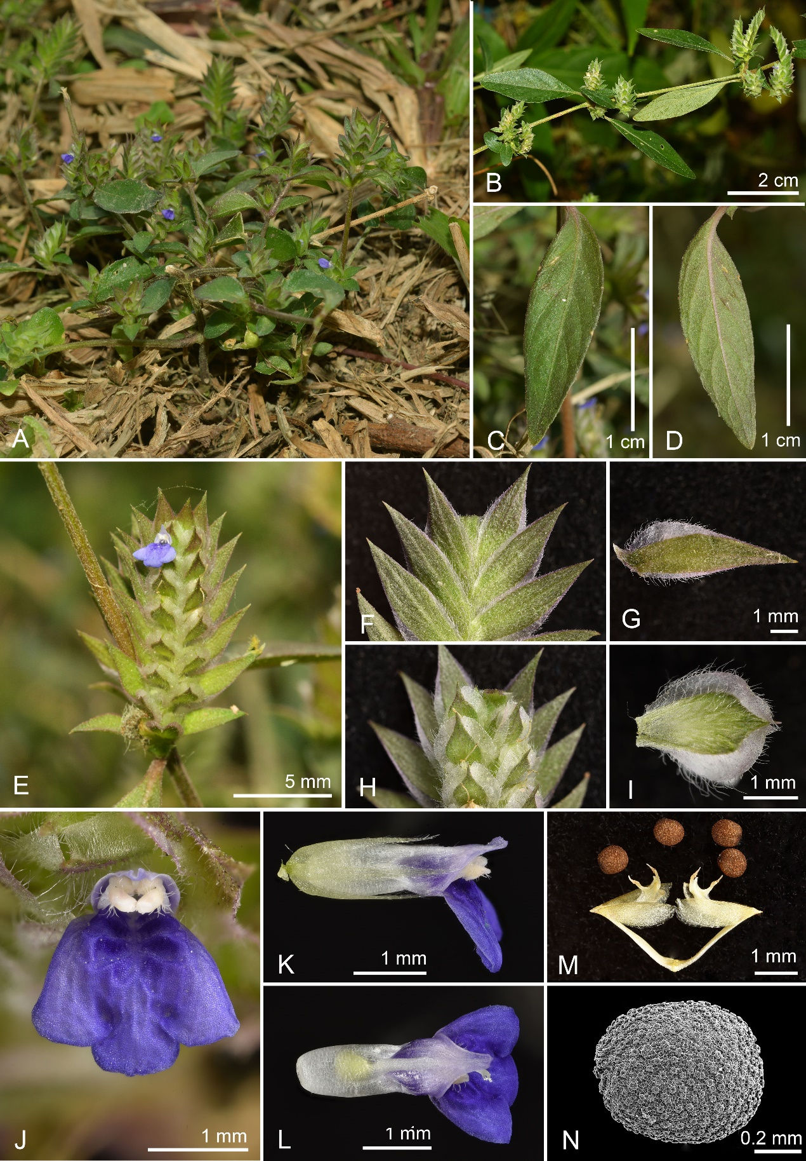

Fig. 1. *Rungia pectinata*. A, Habit; B, Branch; C, Leaf, upper surface; D, Leaf, lower surface; E, Inflorescence abaxial view; F-G, Sterile bracts; H-I, Fertile bracts; J, Flower; K, Calyx and corolla side view; L Corolla upper view; M, Fruit and seeds ; N, Scanning electron microscope photo of seed. (*C. H. Chen 13305*).

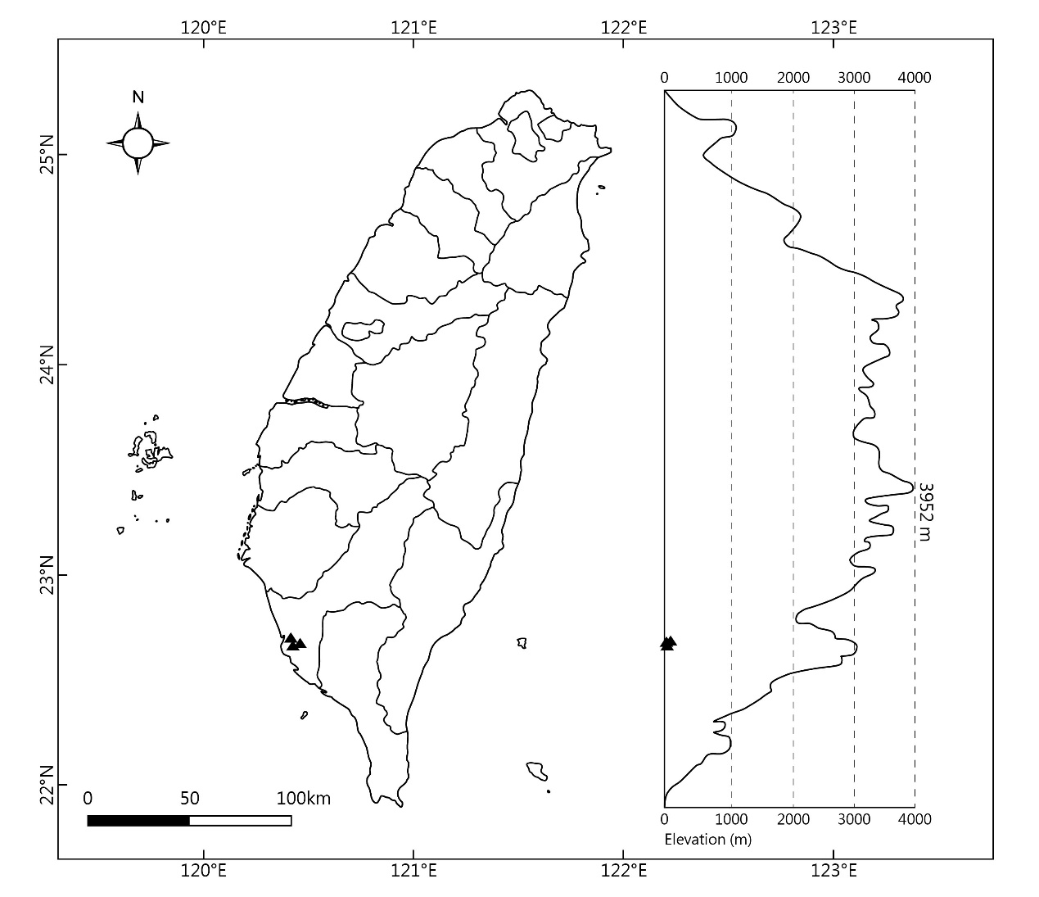

Fig. 2. Distribution map of *Rungia pectinata* in Taiwan (triangles).